From Tactile to Virtual-Using a Smartwatch to Improve Spatial Map Exploration for Visually Impaired Users

【Main Content】：

Tactile raised-line maps are paper maps widely used by visually impaired people. We designed a mobile technique, based on hand tracking and a smartwatch, in order to leverage pervasive access to virtual maps. We use the smartwatch to render localized text-to-speech and vibratory feedback during hand exploration, but also to provide filtering functions activated by swipe gestures.

【Contribute】：

1. a novel solution for VI users to explore virtual maps with data filtering, using a hand tracking technique and a smartwatch,
2. the experimental comparison of the usability of raised-line maps and virtual maps, and
3. a case study relying on a real map exploration with comparison of two sets of data.

【There are four main ways for visually impaired users to browse digital maps】：

Use keyboards, use haptic devices, and use touchpads or tablets, smart watches.

(Detail in Related work-Virtual maps )

【Tactile raised-line maps】：

Tactile raised-line maps have two main advantages: information is tactile, and spatial exploration is direct. They are made according to guidelines (simplification of contours, reduction of the number of elements, legends, etc., see e.g. [26]). These maps contain important elements:

- Contour of areas, rendered through raised lines;

- Points of Interest (POI) and labels represented with specific tactile symbols ;

- a Braille legend describing each area and POI;

- Data associated to each area or POI, for instance the population of a region. In raised-line maps this information is usually written outside the map with Braille.

【Apparatus】：

Principal：

**Tactile raised-line maps**

**Hand tracking**

**Using a smartwatch for localized feedback**

**Plain exploration：**

Plain exploration is the exploration of a virtual map equivalent to the exploration performed on a raised-line map: each element on the map is rendered.

Input interaction: The smartwatch is only used as an output for this technique.

Feedback: We combined auditory and vibratory feedback. TTS reads out information underneath the hand, such as the name of the region and its population. A 100 ms vibration notifies the transition from one region to another one. A continuous vibration means that the hand is outside the map.

**Filter exploration:**

Filtering data before exploration allows reducing the amount of information to render through TTS, and thus reduces the user’s cognitive load. The filtering allows selecting a sub-range of values, for instance regions with more than 100 thousand residents. To perform the filtering, users make swipe gestures on the smartwatch.

Input interaction: A succession of horizontal finger swipes on the smartwatch reads out the filter values (depending on the scenario). A double-tap selects the current filter.

Feedback: After selection, only the data that corresponds to the selected filter is read out. According to the filter state, TTS reads out information underneath the hand, such as the name of the region and its population. As in the Plain mode, a 100 ms vibration notifies the transition from one region to another one. A continuous vibration means that the hand is outside the map.

**Grid-Filter exploration:**

As previously mentioned, filtering reduces exploration time and user’s cognitive load. However, it can be difficult to find certain regions in a map especially if they are small. To get a full glance of a map without missing any region, one solution consists in using a 3x3 grid [28], i.e. reading out the information concerning all the regions contained in each cell of the grid.

Input interaction: When the hand is lying onto the table, the user explores the map in Plain mode. When the hand is moving over the table, the user explores the map in Grid mode.

Feedback: At the surface level, the interaction is identical to the aforementioned Filter technique. At the Grid level, a 100 ms vibration notifies the border between two cells of the grid. A double vibration pattern is used to notify the user when he changes the interaction level, i.e. when he is raising or lowering the hand.

【Experiments】：

E1 : MAP EXPLORATION

The purpose of our study was to compare the effectiveness of our virtual map version with the raised line print version during the exploration mission. We evaluated each of these technologies on a virtual map.

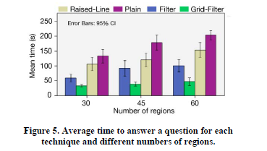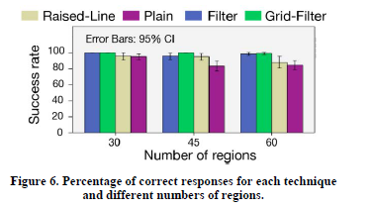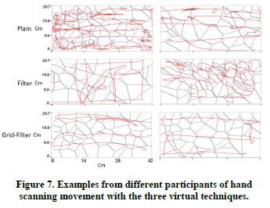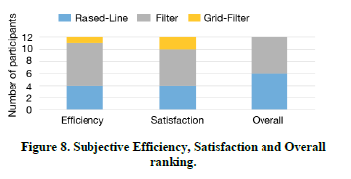

Experimental summary: Grid filter technology is more efficient, but it is not the preferred method.

E2 : EXPLORING MULTIPLE DATASETS

The purpose of the second study was to verify the use of the best techniques (filters and grid filters) in more realistic and complex scenarios: use two types of data (unemployment rate and population density) to browse the US map. Finding data-related trends is a common task in spatial data visualization [28].

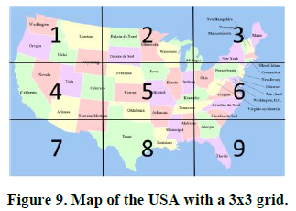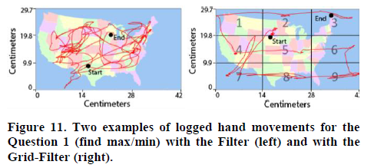

【Conclusion】：(Detail in Paper)

**Raised-lines vs. virtual maps**

**Smartwatches for pervasive access to maps**

**Two hands for virtual exploration**

**Zooming and panning**

**Mid-air gestures**

**ALL：**

In this paper we proposed virtual spatial map exploration techniques as an alternative to regular raised-line maps. Our techniques are based on the combined use of hand tracking and a smartwatch for feedback and input. We defined three types of map exploration: Plain, Filter and Grid-Filter. In a first study, twelve visually impaired users explored a set of randomly generated maps by using these three techniques as well as the classical raised-line approach. Results show that using the Grid-Filter approach is the fastest, but generates discomfort. In a second study, we observed four VI people who explored two types of data (unemployment and population) on the USA map. Results show that virtual techniques are usable to perform complex tasks such as finding correlations between the two sets of data.